#### Roles and Users Sections

[Echoes - Land Management](https://echoes-platform.eu/app/main/map-view)

10 Steps

Go to <https://echoes-platform.eu/>

1 - Roles Section

In the Administration section, you will see the option of 'Roles' Here you can create and edit the roles you want to assign to users who will use the platform.

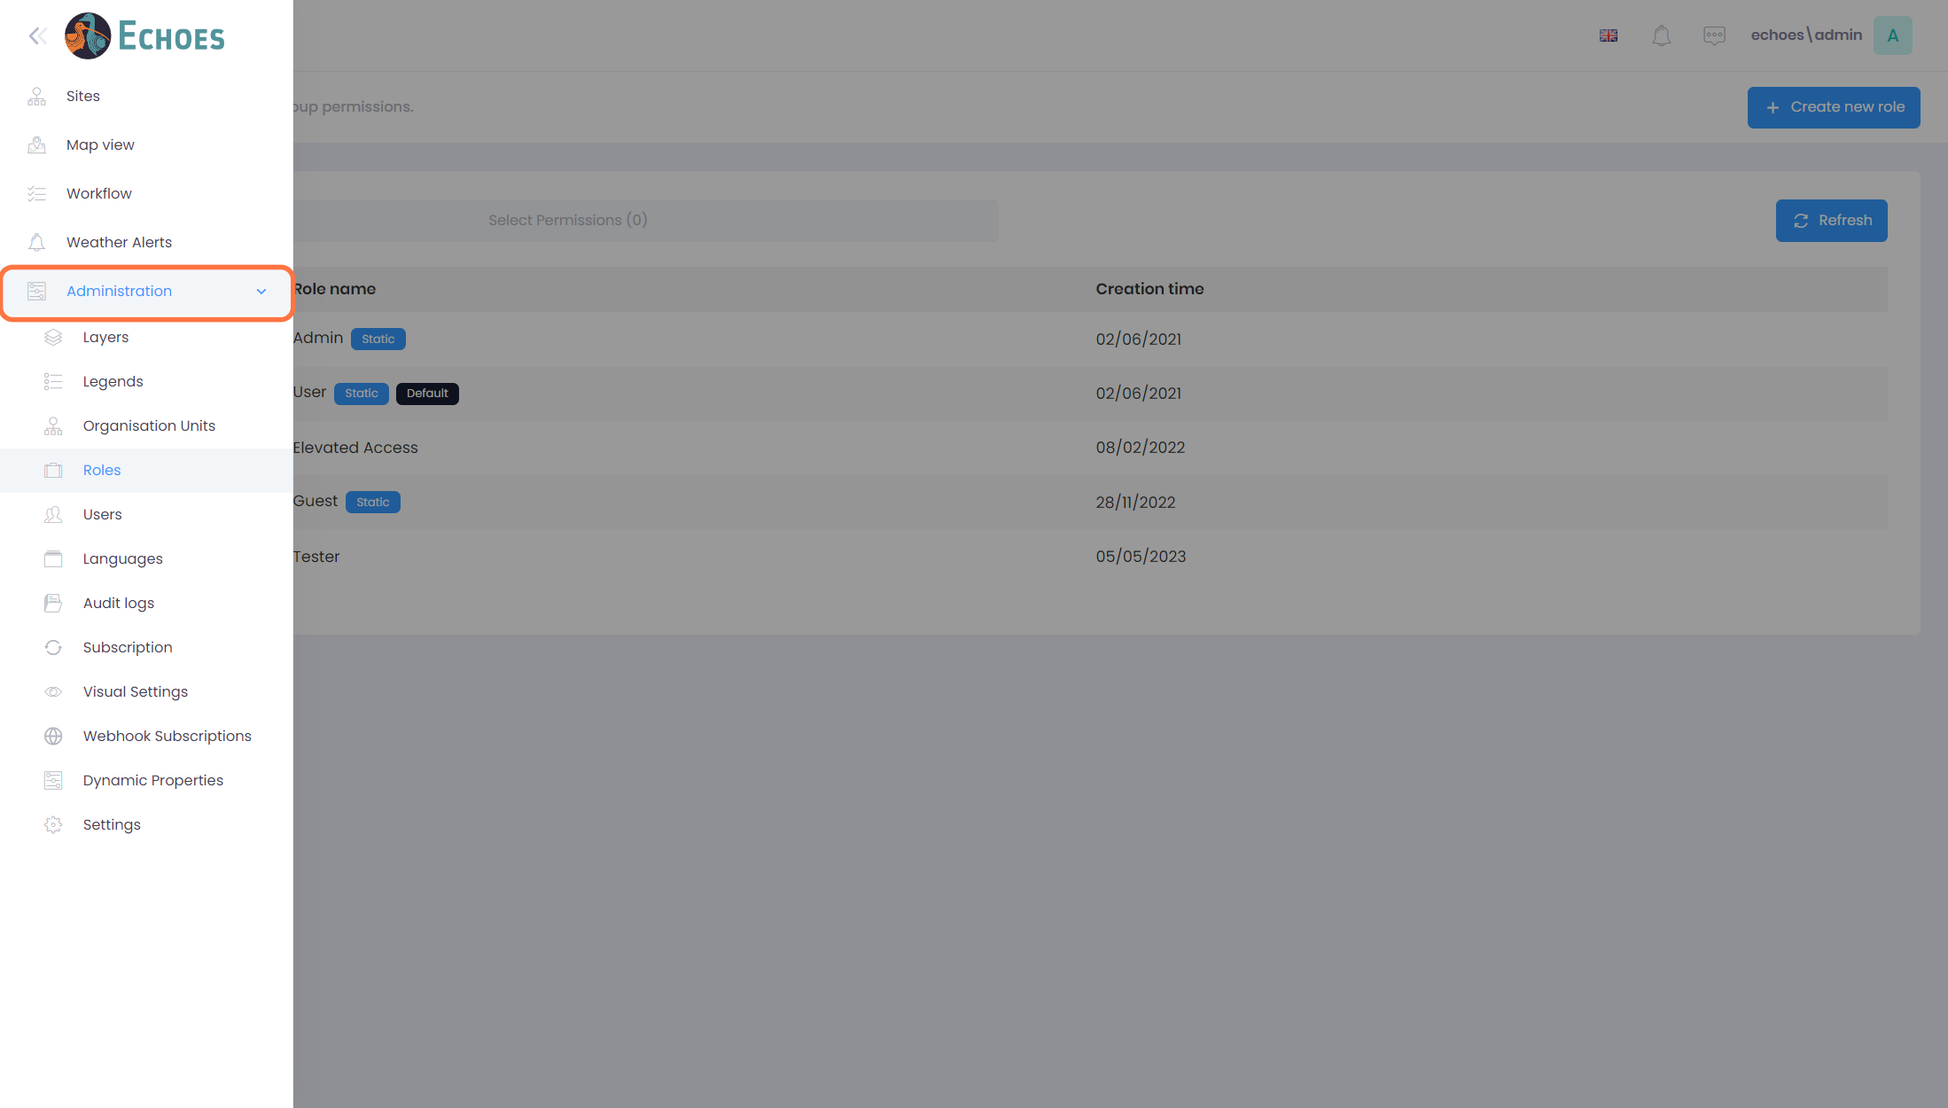

2 - Roles List

Once in the roles section you will see a list of all the roles available to assign to your users. By clicking on the 'Action' button of the role, you have the option to either Edit the current role, its information or the permissions for that role, or Delete the role entirely.

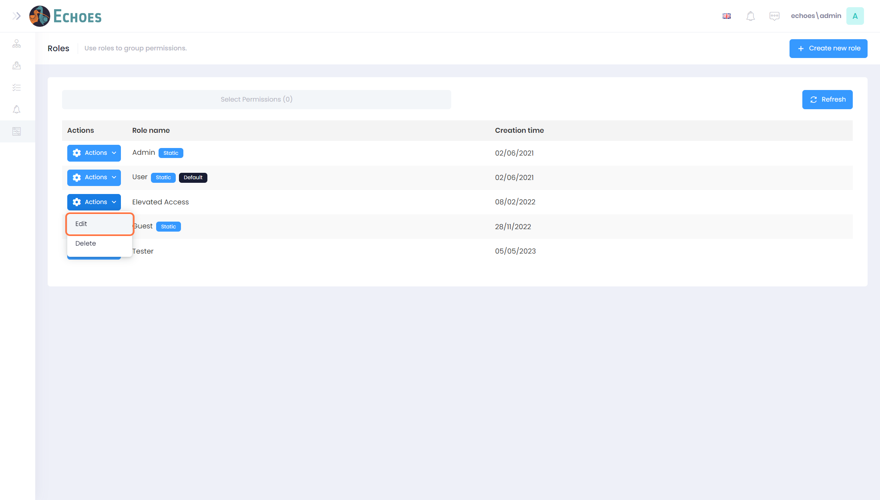

3 - Create New Role (1/3)

You can create a new role by clicking on the 'Create new role' button in the top right-hand corner.

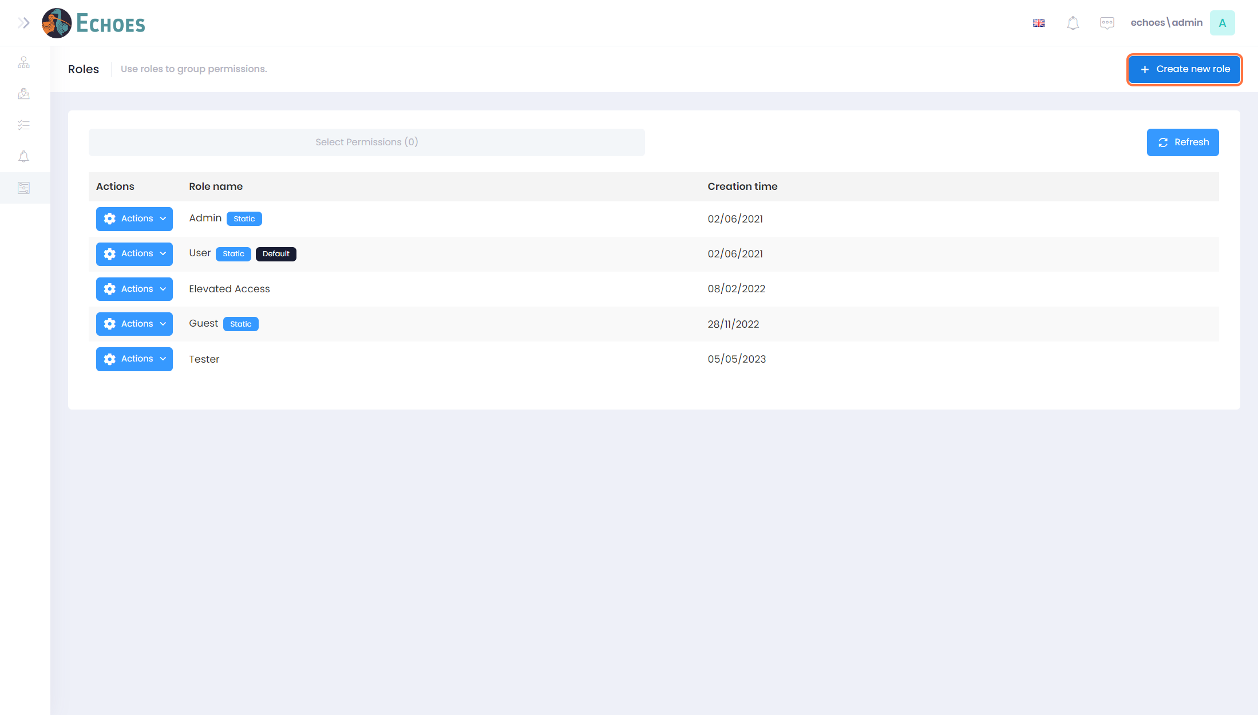

4 - Create New Role (2/3)

Here you can give your roll a name.

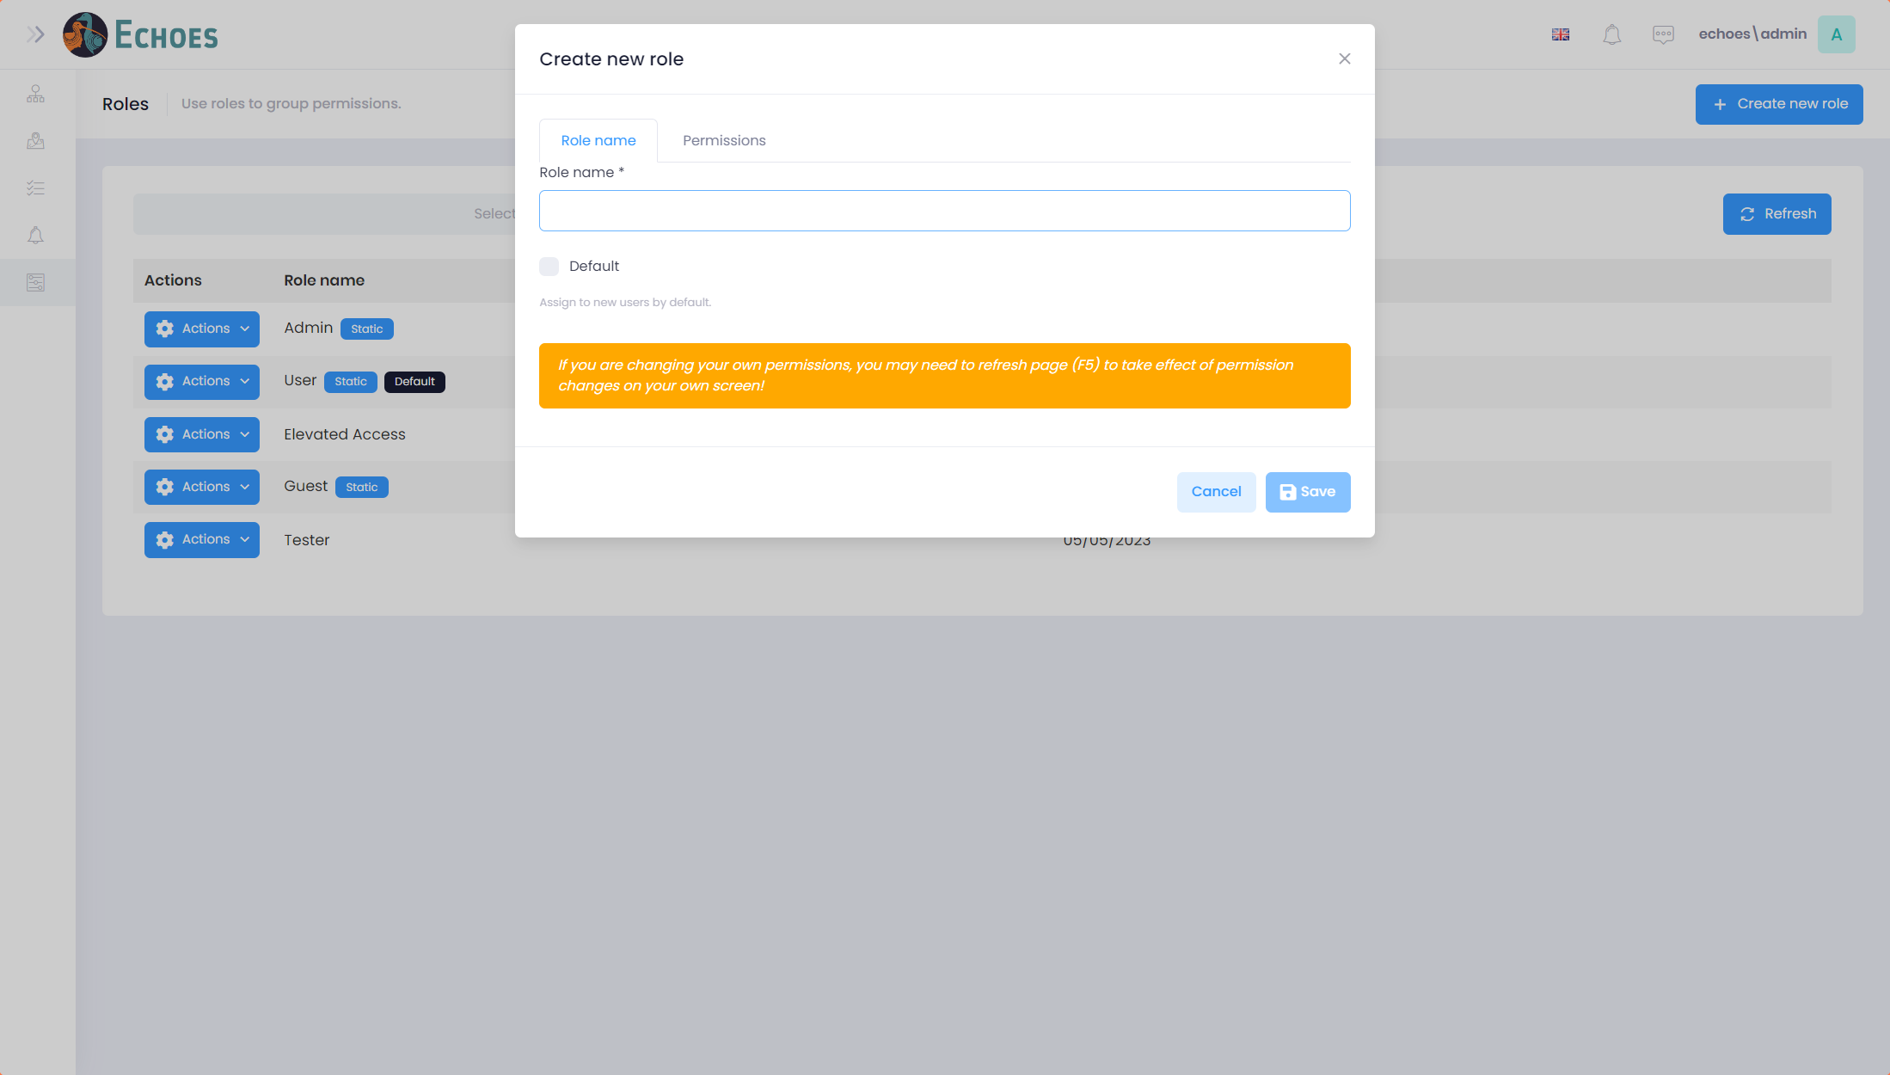

5 - Create New Role (3/3)

In the Permissions tab you will see a list of the available section your grant or deny a users access to if they are assigned this role. Once this is complete, click the 'Save' button to save your new role.

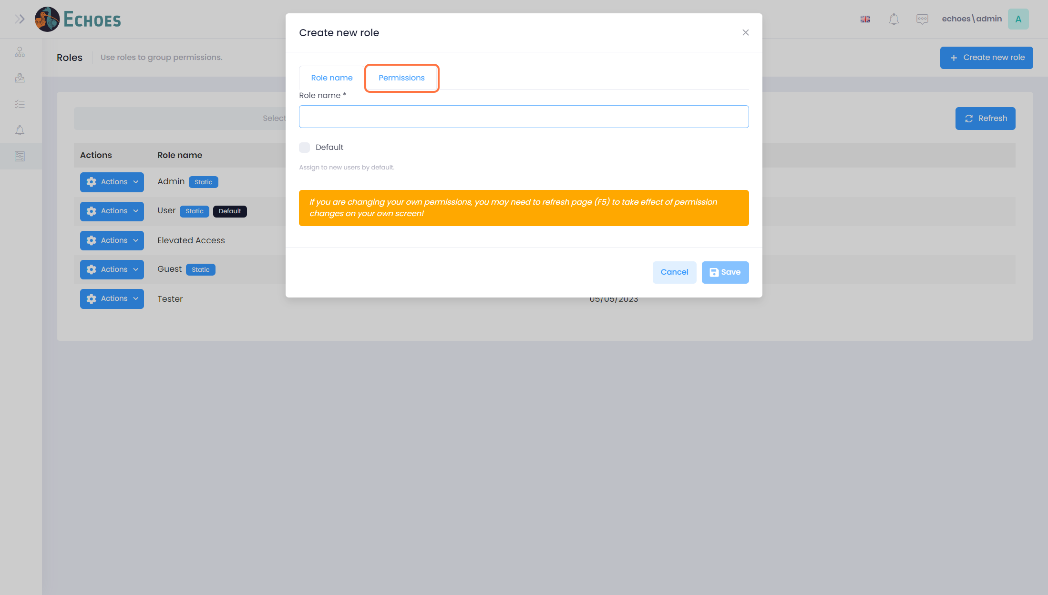

6 - Users Section

In the Administration section, you will see the option of 'Users' Here you can create and edit the users of the platform.

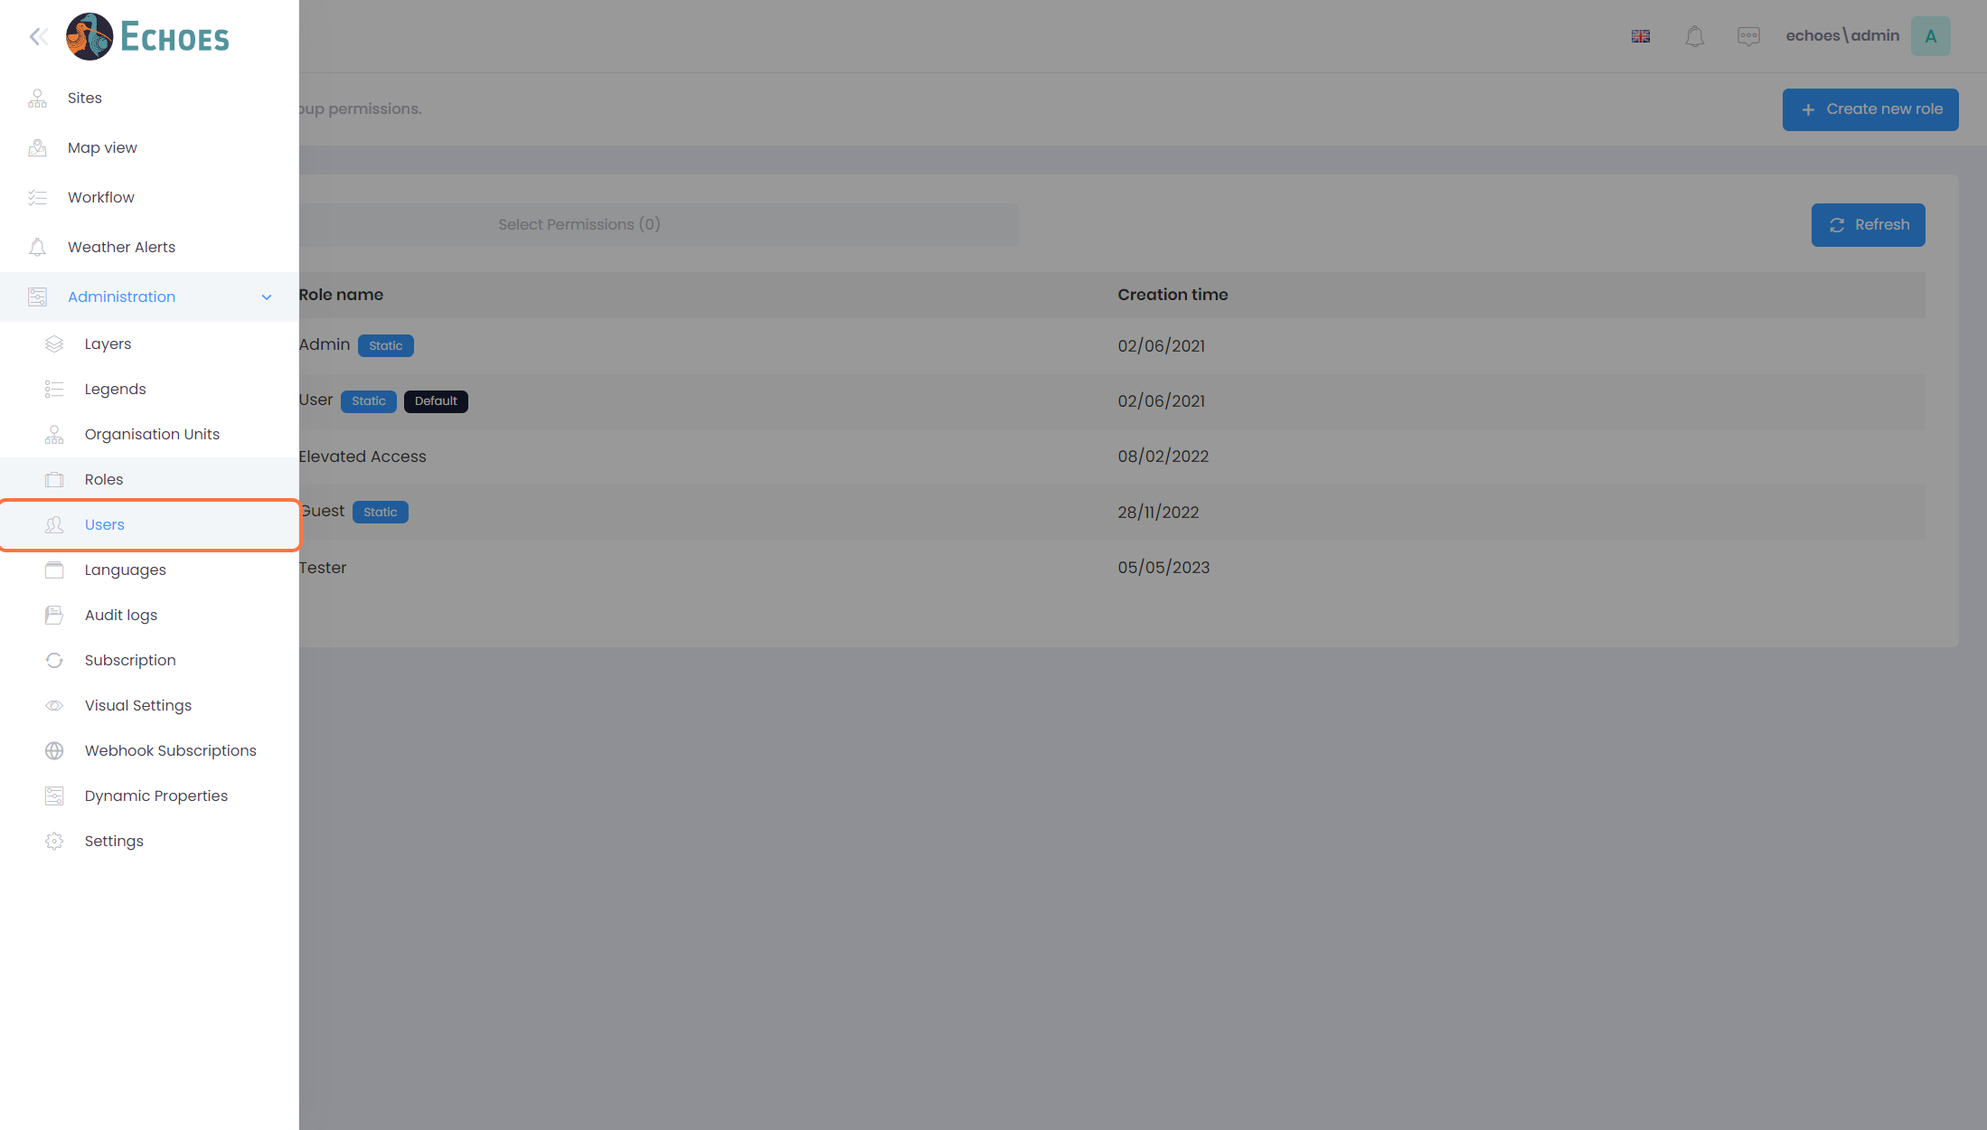

7 - Users List & Actions

Once in the Users section you will see a list of all the users who have access to your platform. In the 'Actions' button you have the option to:

* **Login as this User:** You will be able to login to this user account and see what they see when they log in with their credentials
* **Edit:** Edit the information about the user, username, password, roles etc.
* **Permissions:** You can individually change the users' permissions here, to add or remove permissions from their given role.
* **Unlock:** If a user's locks their account with incorrect passwords, you can unlock them here.
* **Dynamic Properties:** This is for the IT admins.
* **Delete:** Permanently delete a user's account.

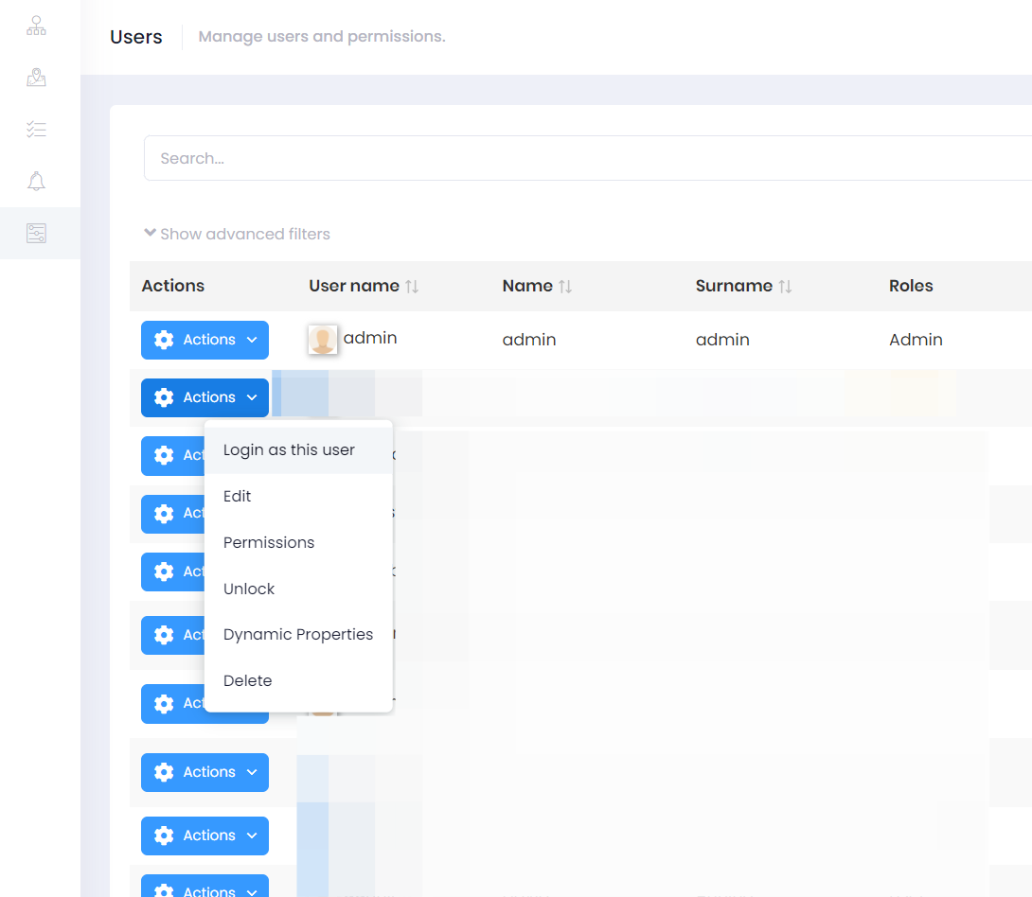

8 - Create New User (1/3)

To create / add a new user, click on the 'Create new user' button in the top right-hand corner.

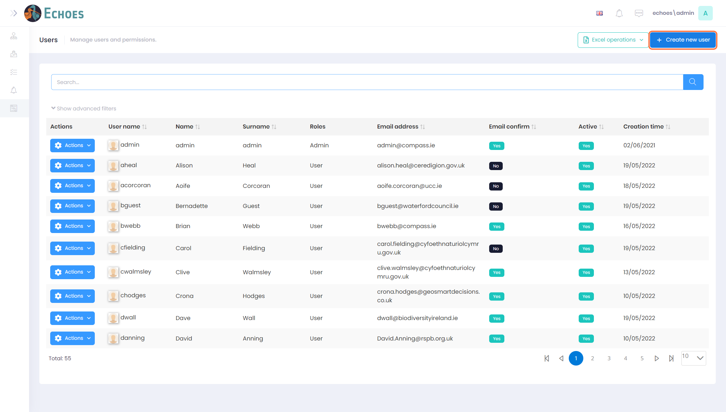

9 - Create New User (2/3)

Here you can now add the information about the user, as well as clicking the options at the bottom for more control over the activation of user's account. E.g., Deselecting the 'Set random password' will allow you to enter a password for that user if you need to do so.

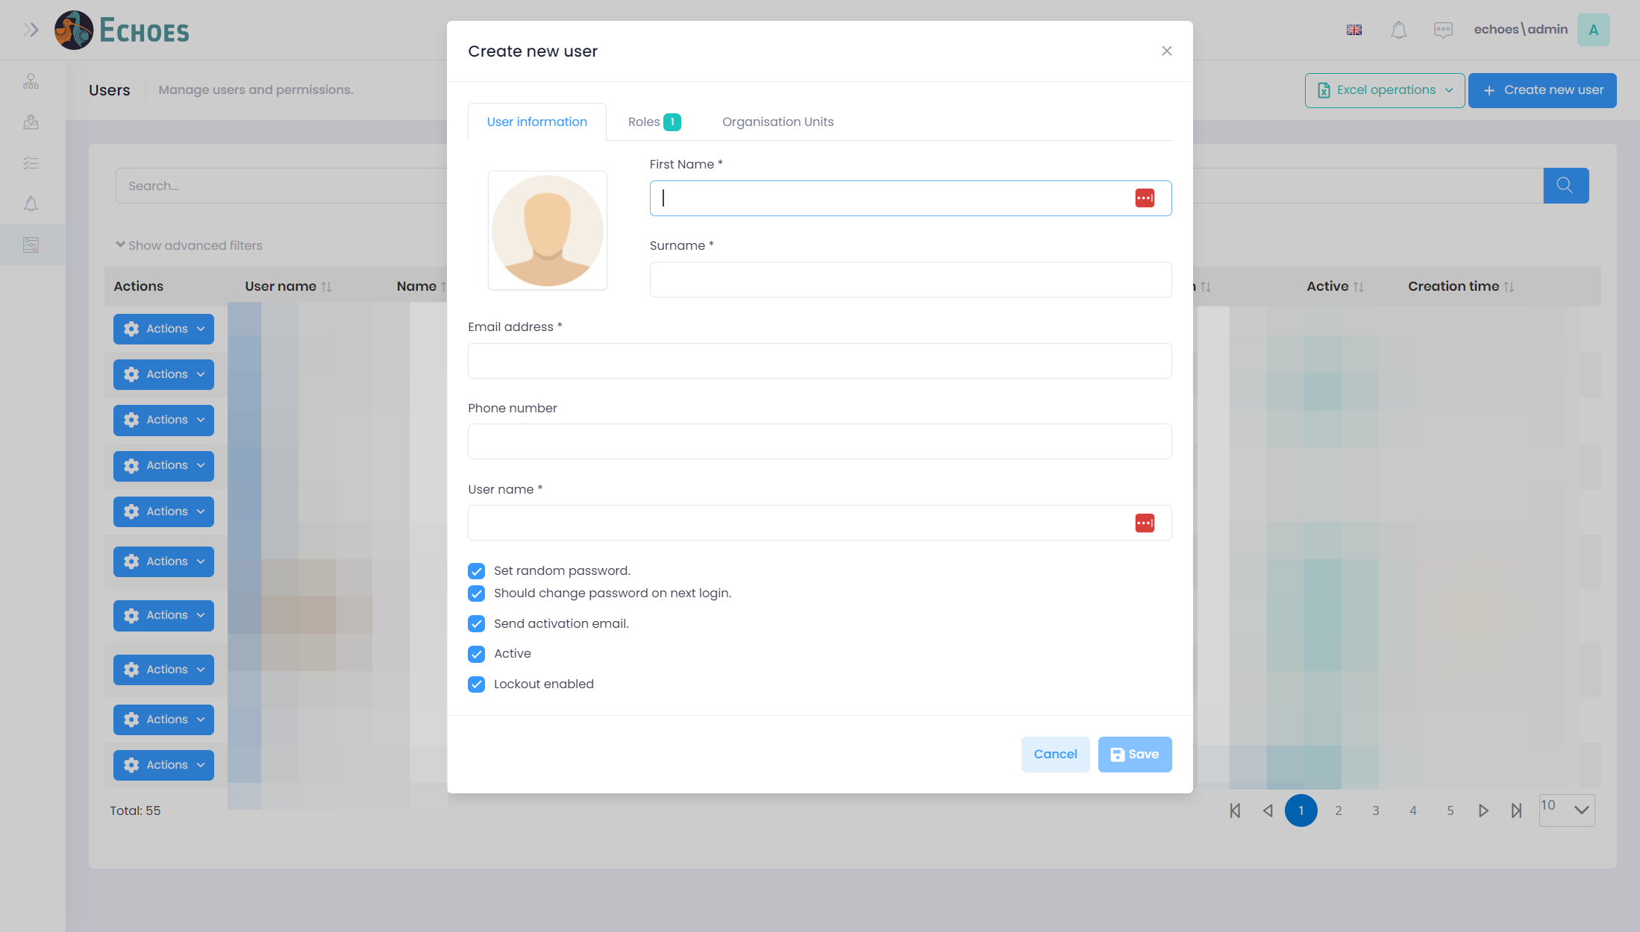

10 - Create New User (3/3)

In the 'Roles' tab you can then choose the role you want to assign to this user. You can select more than one if needed. 'User' being the default unless changed in the roles section.

